List of the algorithms

The following document contains a list with a short reminder of the algorithms implemented in the CmnIP (Common Image Processing) library.

The library contains a collection of algorithms from different libraries (where available) to solve common visualization or image processing problems.

More information are available in the source code.

1. Sample_cmnipcontainer_connectpoints

Estimate the connected points of the border of an image

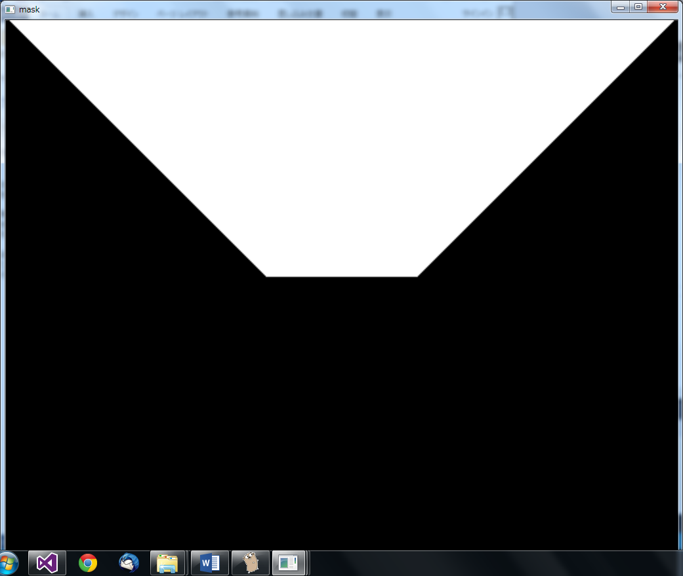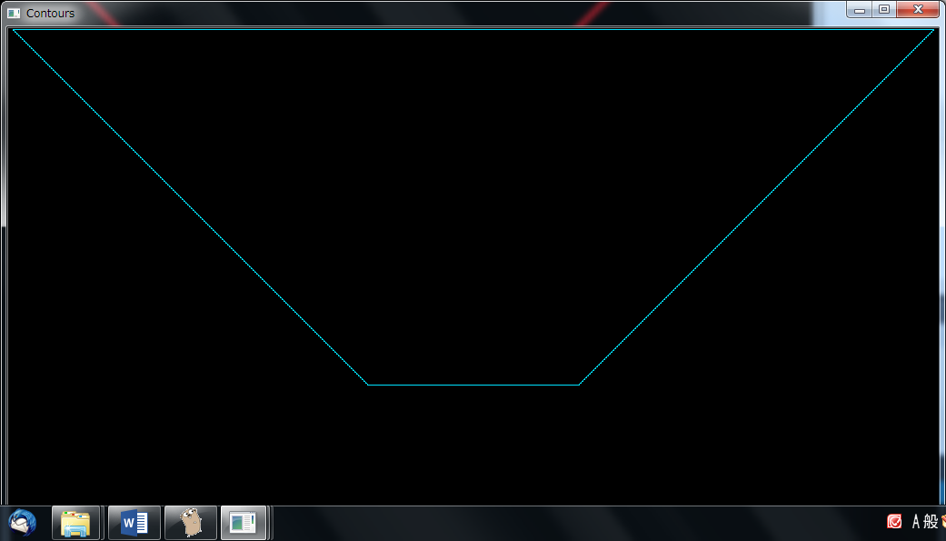

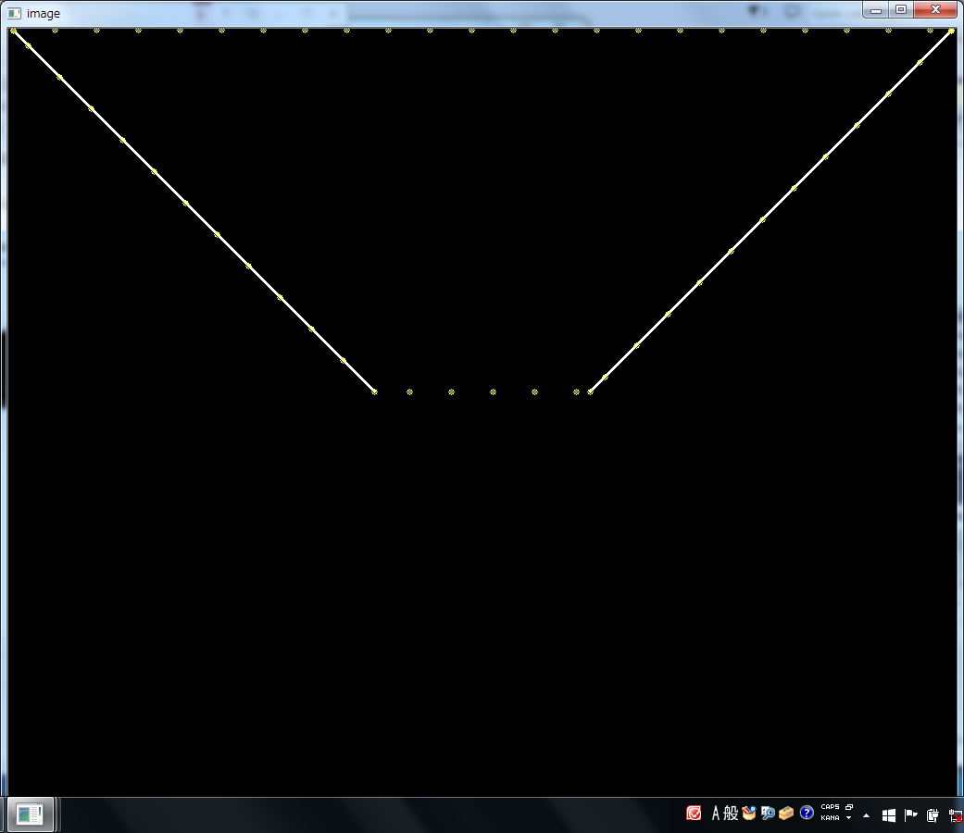

The yellow dots represent the connection points of the border of the area.

1. sample_cmnipcontainer_imagepointsassociation

Example of a container for the associative points in a 2D space.

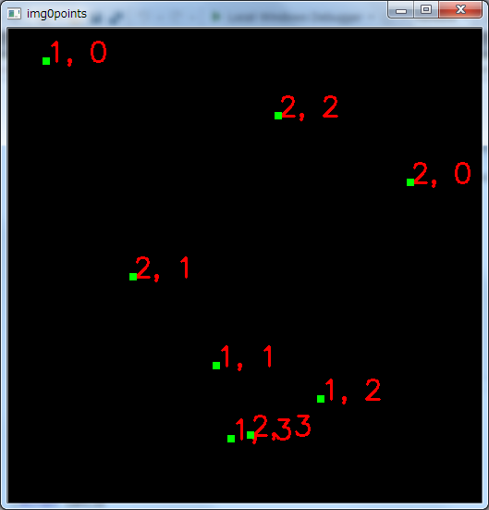

The indexes are: Associated image ID, Associated point ID

1. sample_cmnipcontainer_indextiming

Container with associated the index and timing.

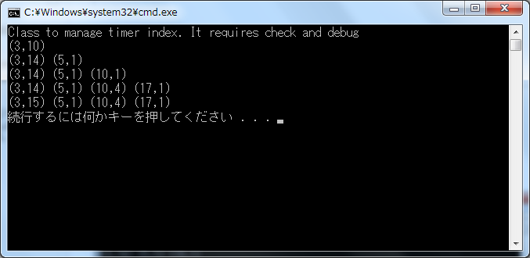

Check the code for more details

1. sample_codify_codifydata

It encode some data inside an image

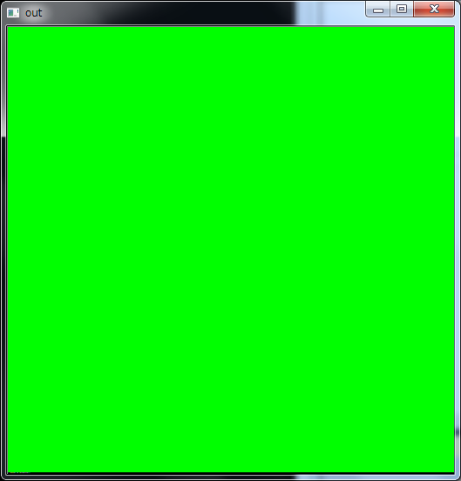

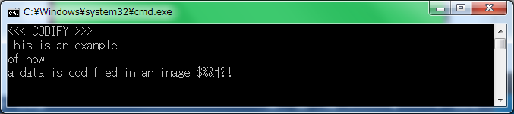

Useful to add some information to the current image (timestamp, sensor data).

1. sample_codify_packunpackimages

It contains a class to memorize a set of images in a single file (pack) and retrieve those images (unpack).

1. sample_draw_chartradar

Display class to visualize values and features in chart radar form.

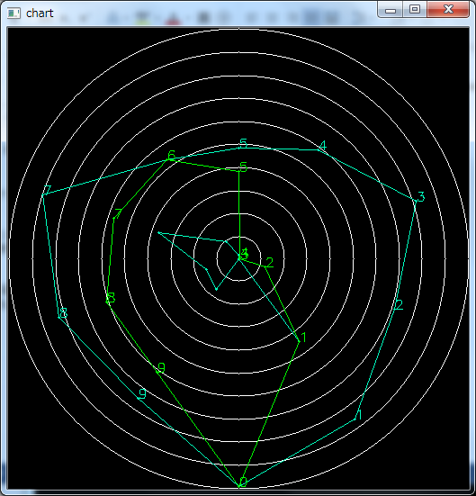

1. sample_draw_coloredrange

Example to display range information in colored mode

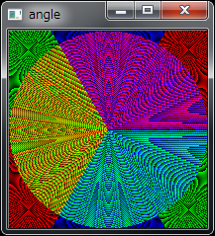

1. sample_draw_histogram

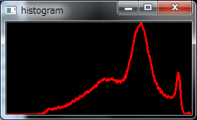

1. sample_draw_hog2image

Third party function to display the HOG features

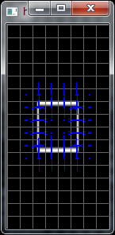

1. sample_draw_map2d

Method to visualize a map with markers on a 2D space

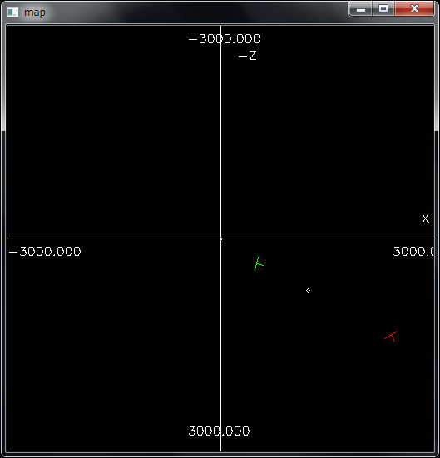

1. sample_draw_opticalflowdrawer

Visualization of the optical flow data

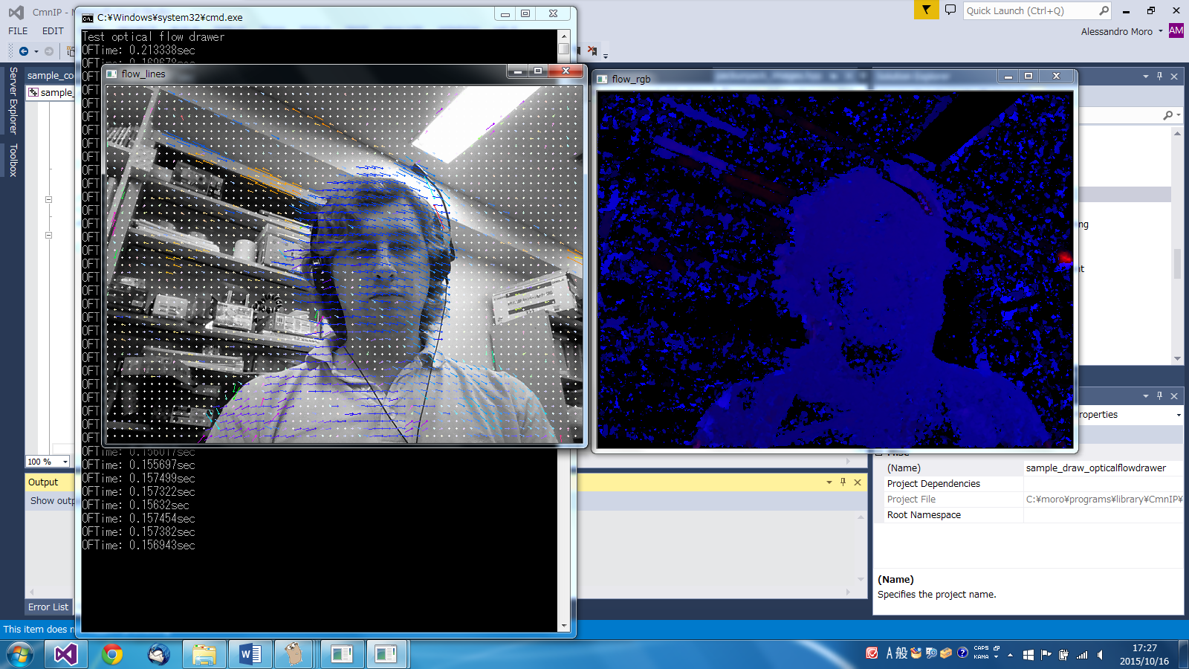

1. sample_draw_pairs

Example of visualization of pairs of points

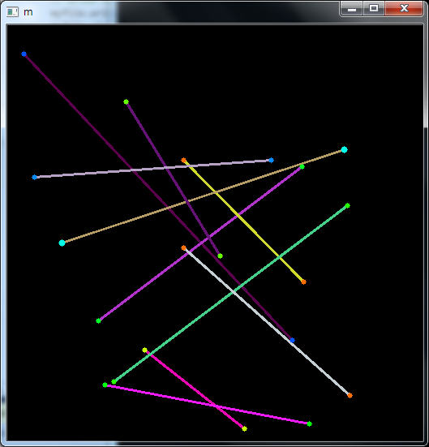

1. sample_feature_densetemplatematching

Example of dense template matching based on histogram analysis

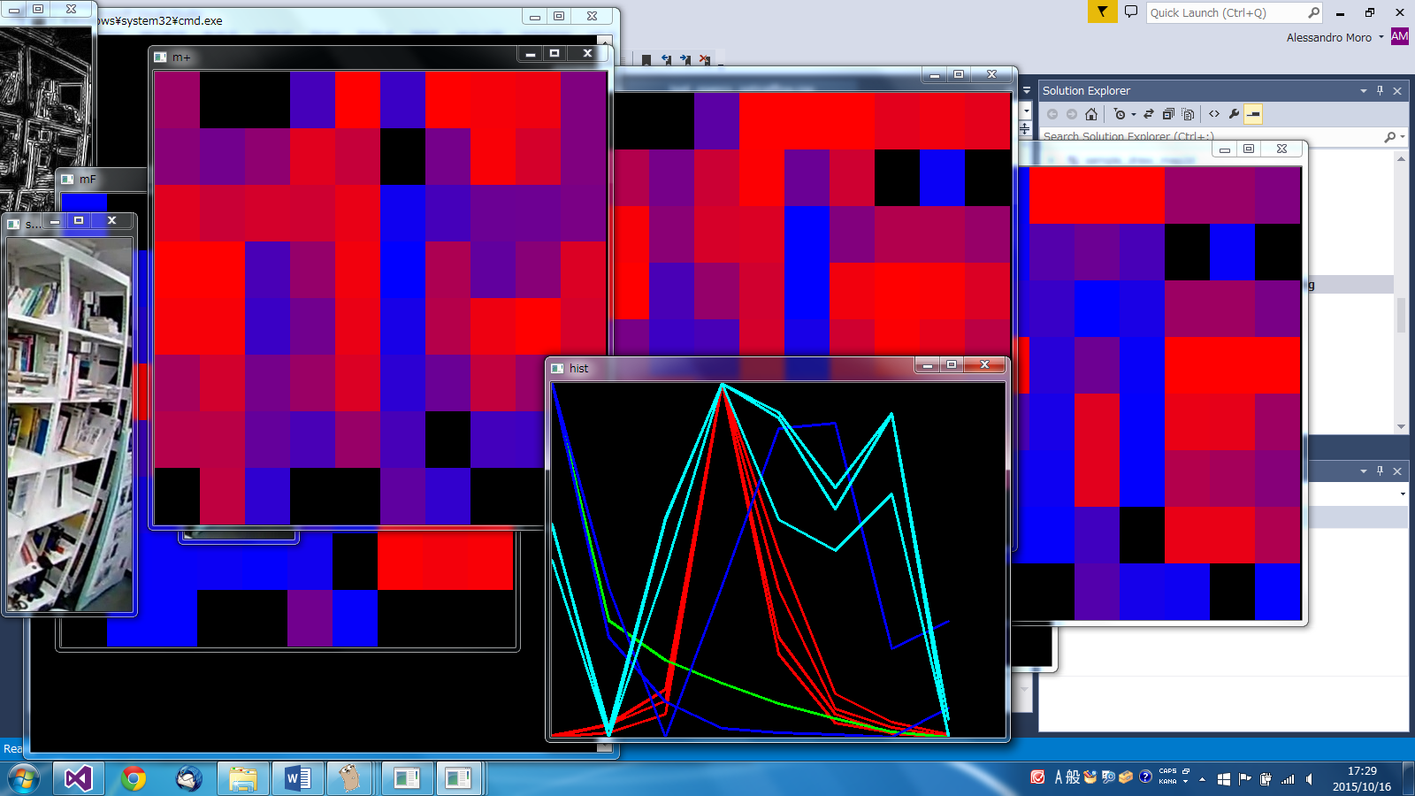

1. sample_feature_featurematching

Example of feature detection and visualization of the values with different viewers

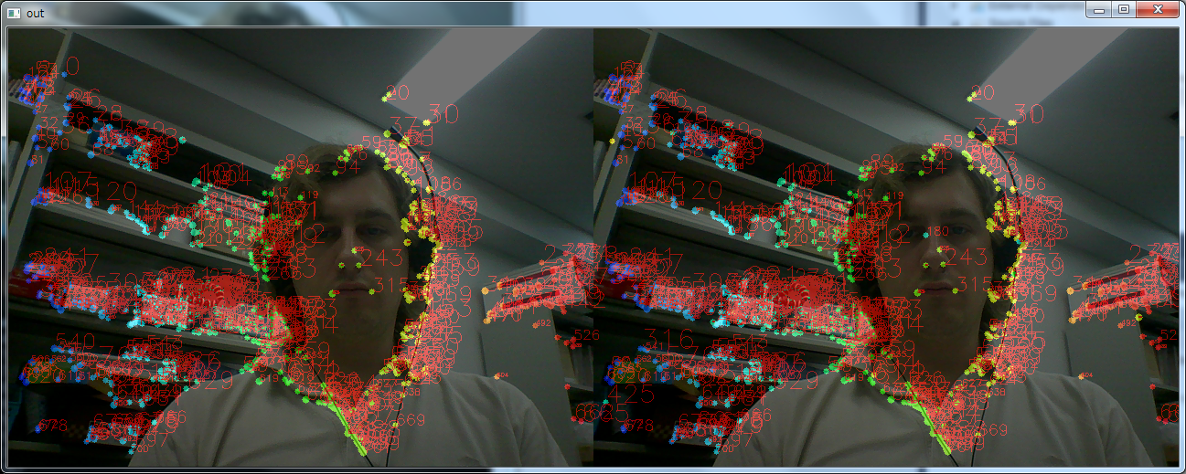

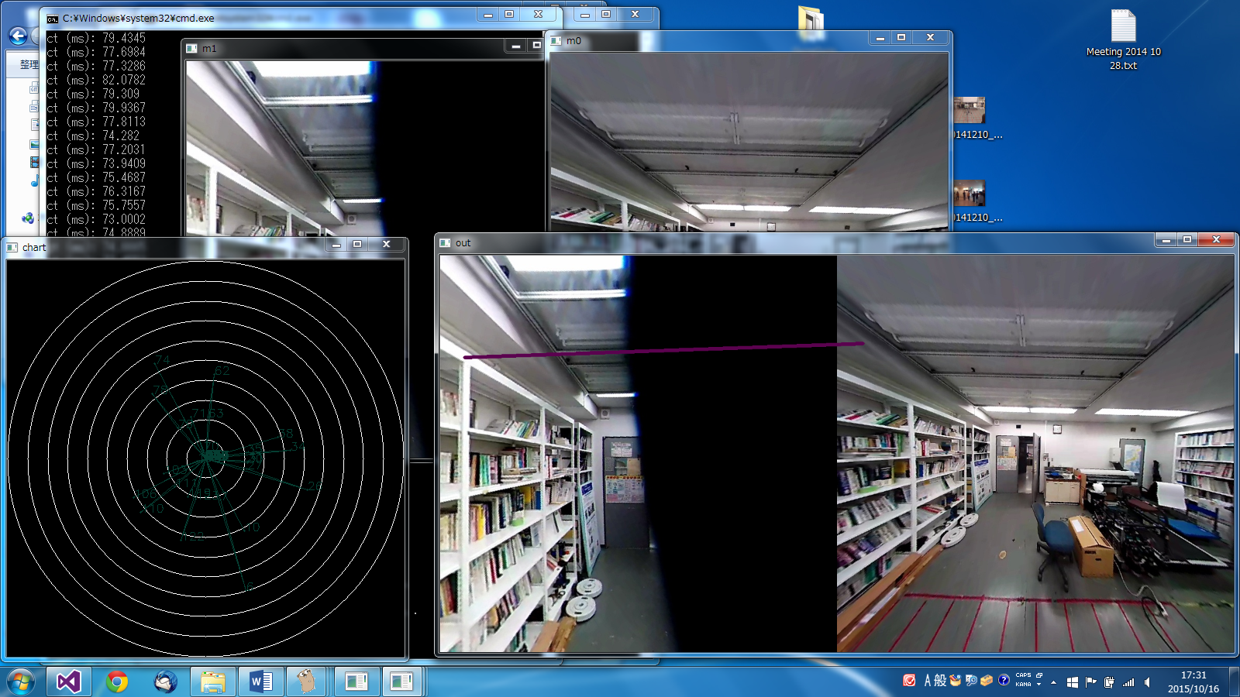

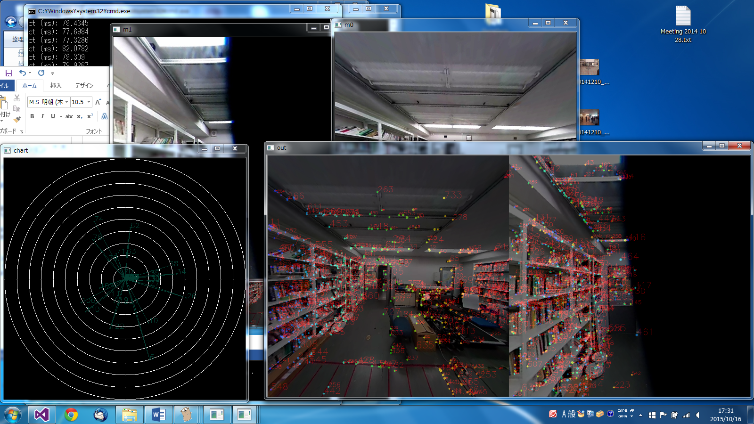

1. sample_feature_lbp

Third party local binary pattern visualization

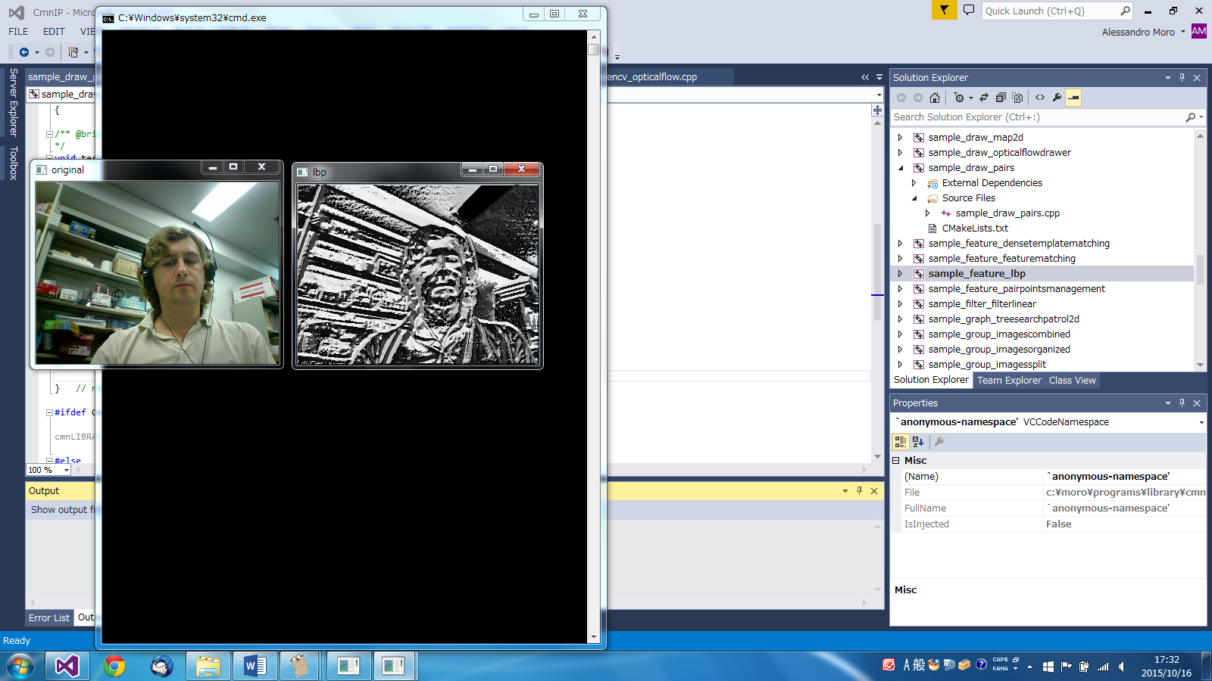

1. sample_feature_pairpointsmanagement

Example of visualization of the feature position associated as pairs

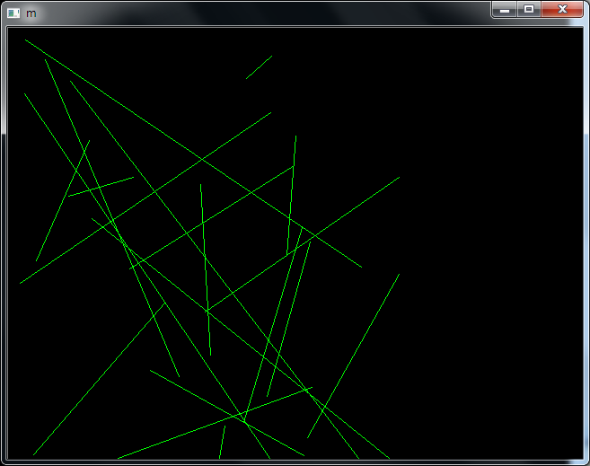

1. sample_filter_filterlinear

Gabor and two Laplace filters

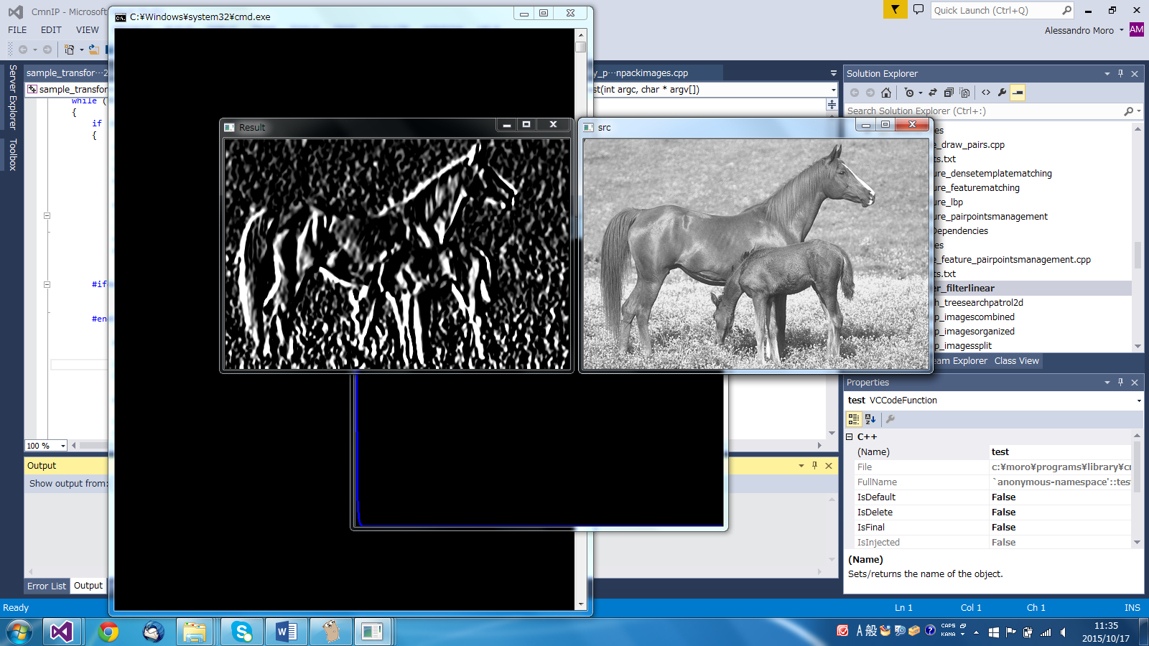

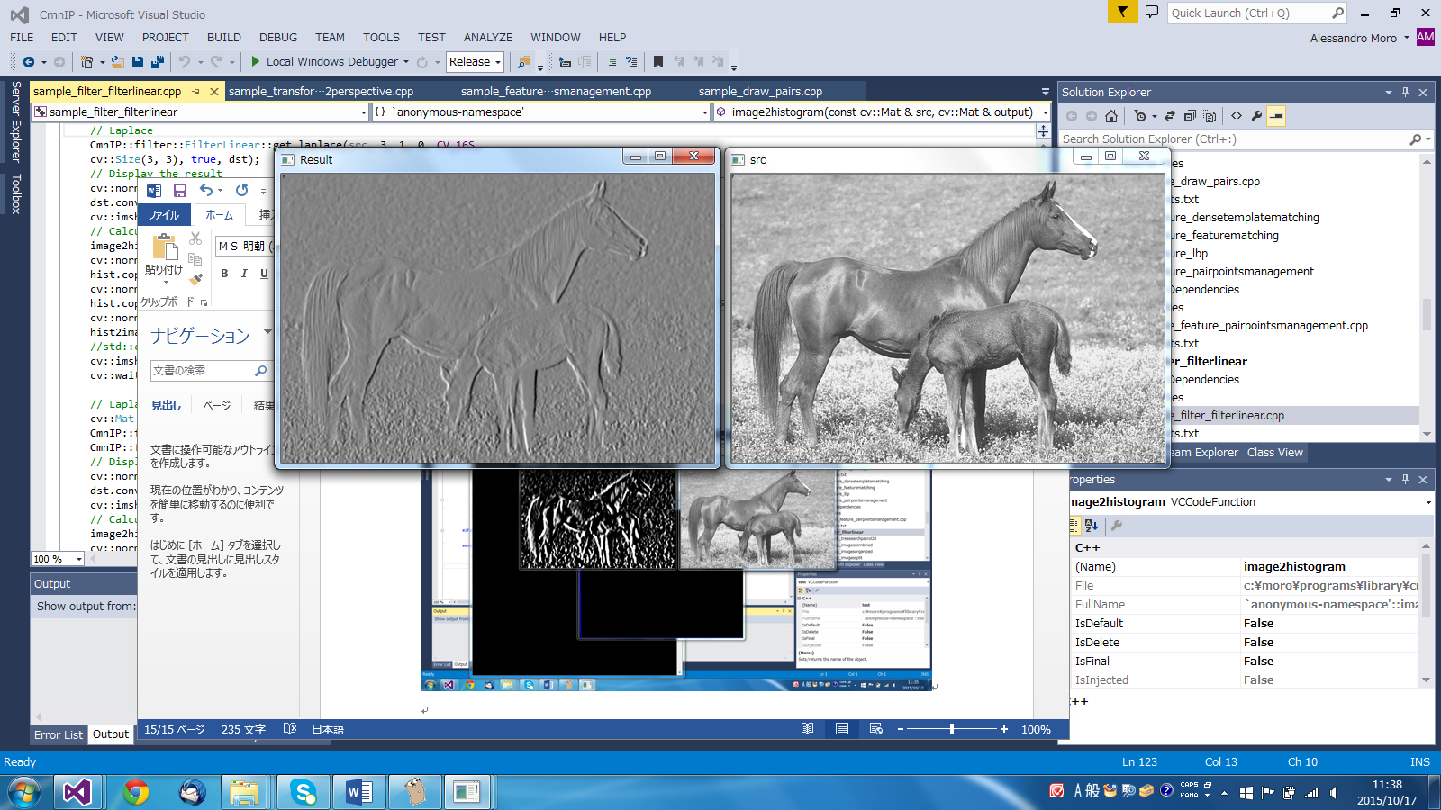

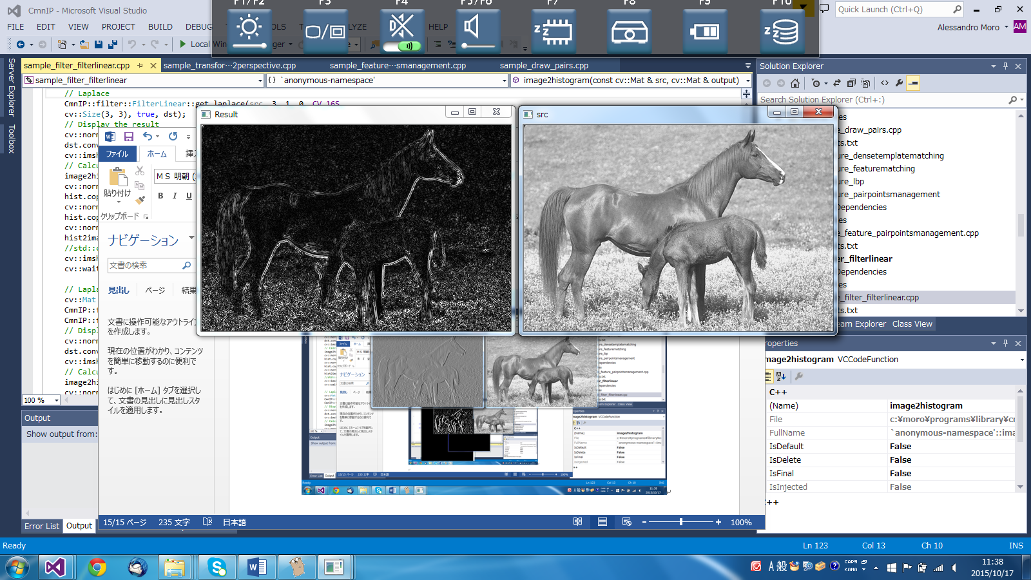

1. sample_graph_treesearchpatrol2d

Simple 2D patrol based on a tree search.

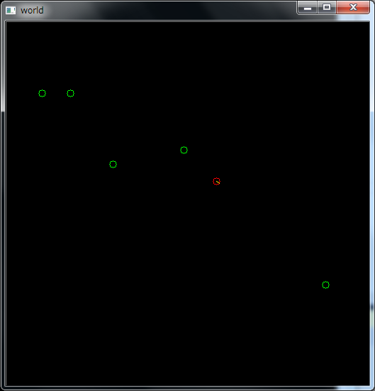

1. sample_group_imagescombined

Example of how multiple images are grouped together.

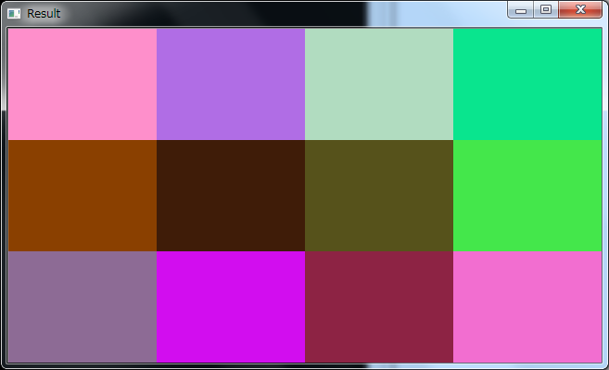

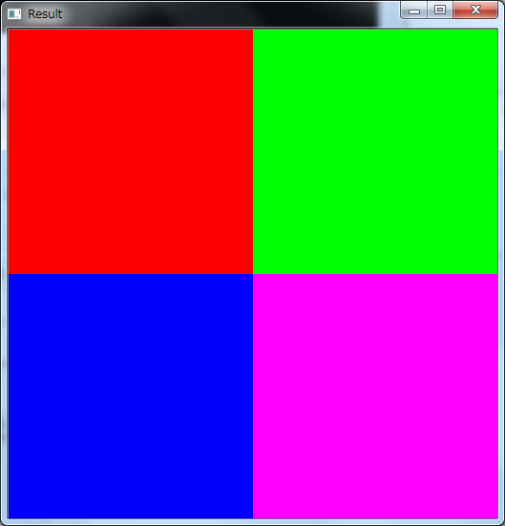

1. sample_group_imagesorganized

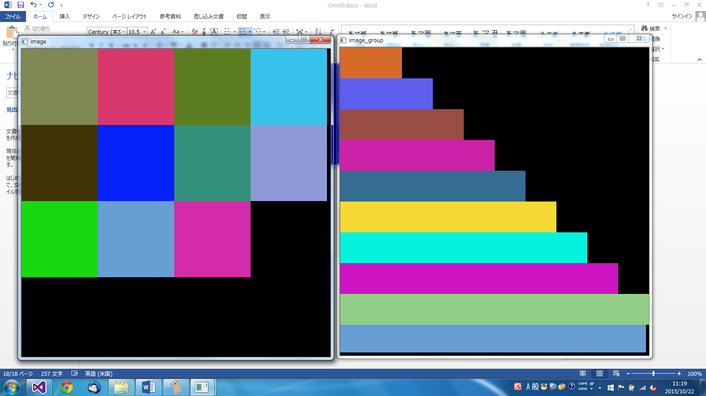

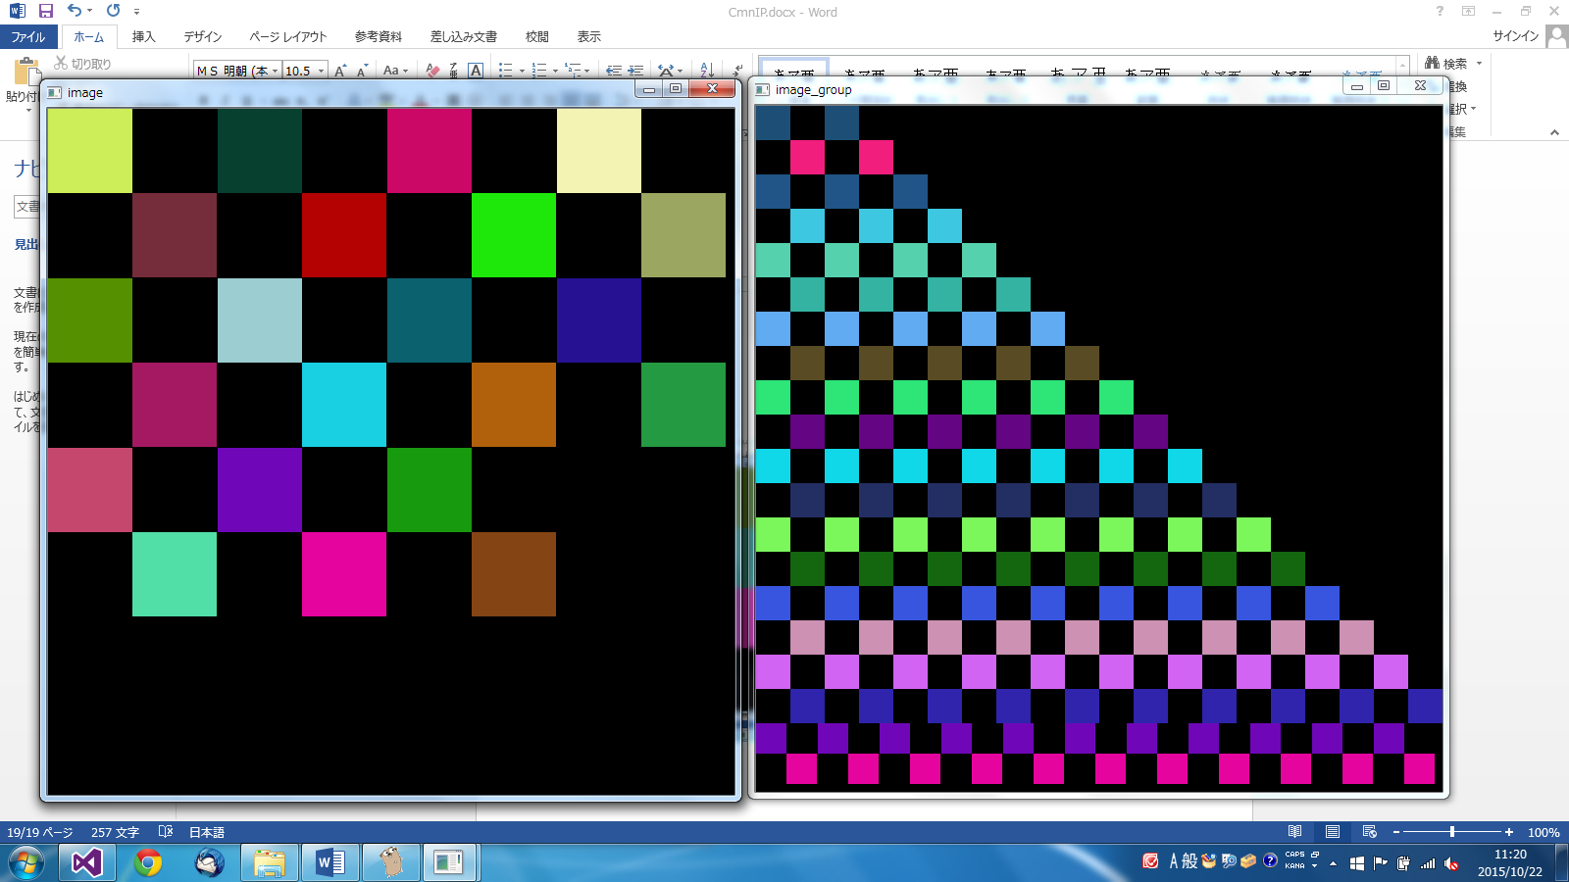

1. sample_group_imagesplit

Source image is split in sub images

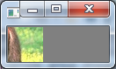

1. sample_group_marker

Some types of markers

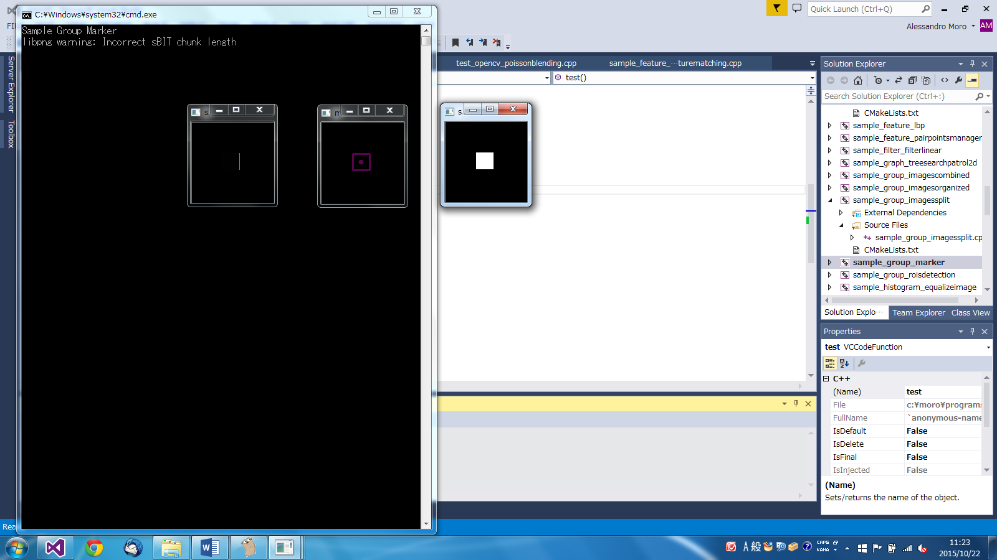

1. sample_group_roisdetection

It uses a feature detection and k-mean clustering to cluster candidate rois

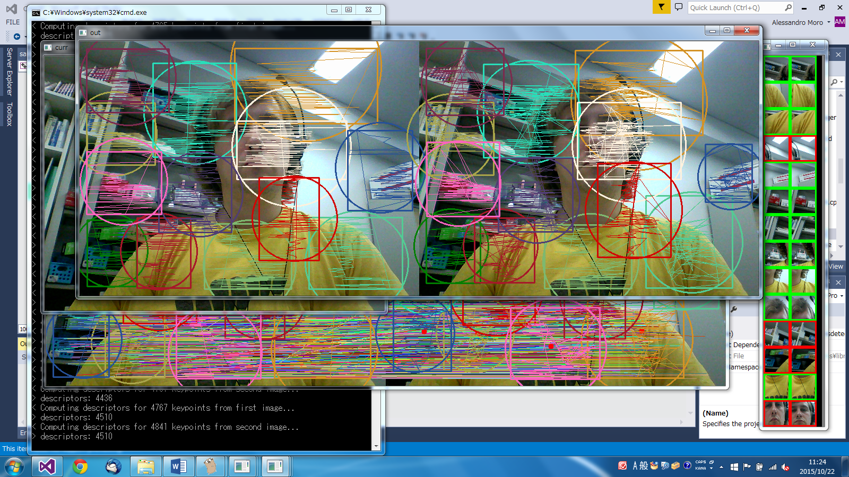

Rois are shown in the right squared side.

1. sample_histogram_equalizeimage

An example of image blending. The image is equalized and an alpha mask is created.

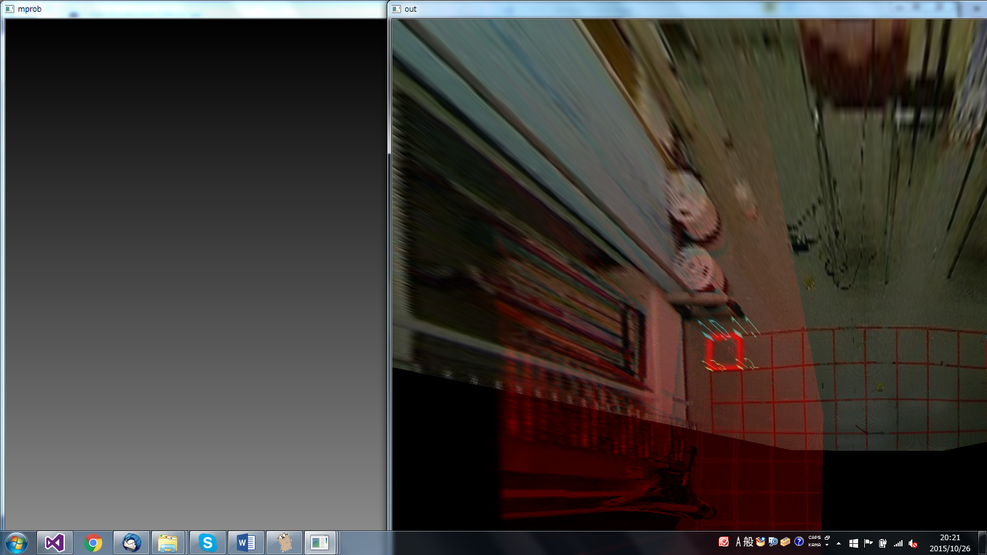

1. sample_measure_imagematching

Use a template matching algorithm to estimate the similarity between the current image and default. It can be used to verify in an image is stable.

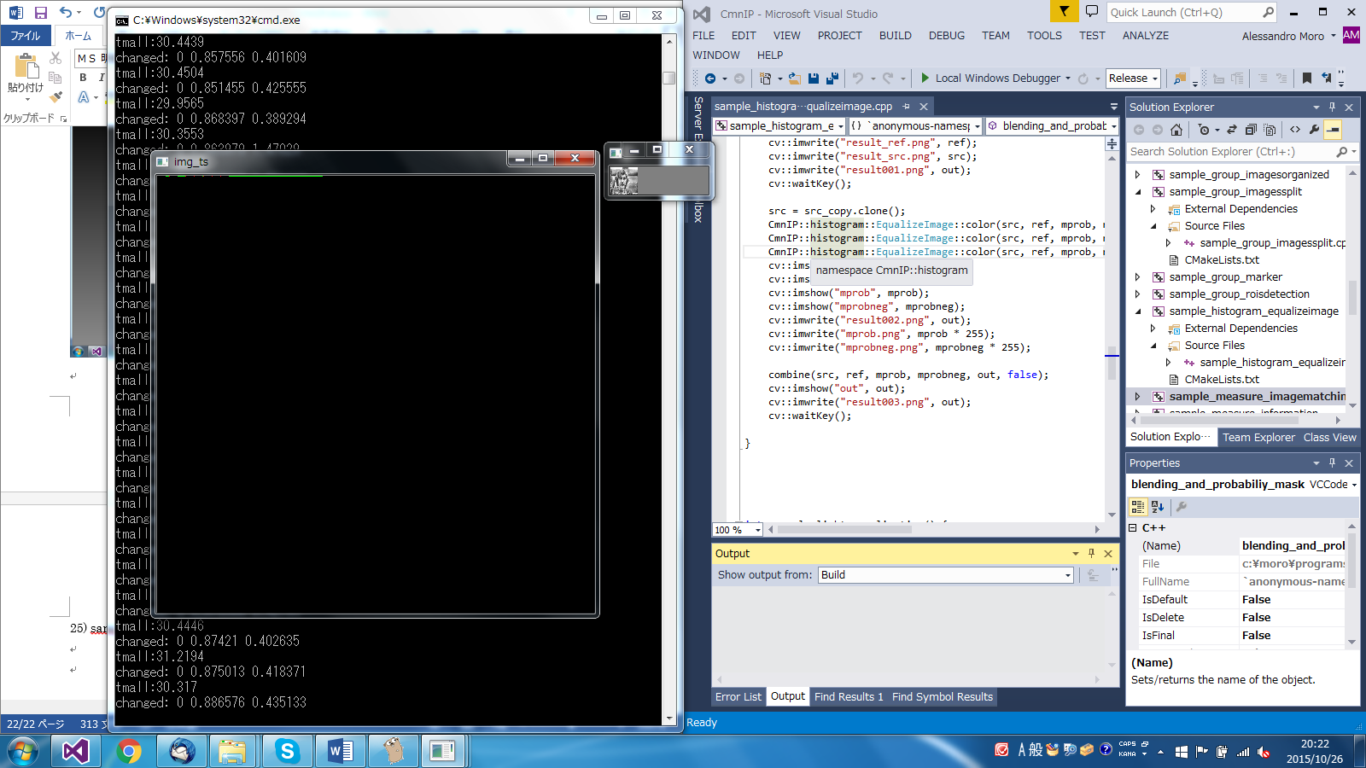

Current video image is rescaled (32x32px). Visible in the small window. The big image turns red when a movement has been detected. Green otherwise.

1. sample_measure_information

Function to measure the quantity of information (entropy) in an image

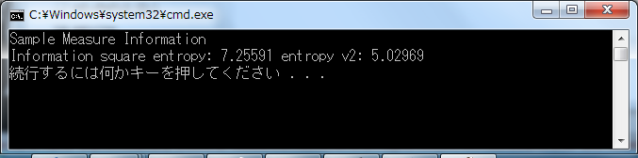

1. sample_measure_moment

It measure the image moment.

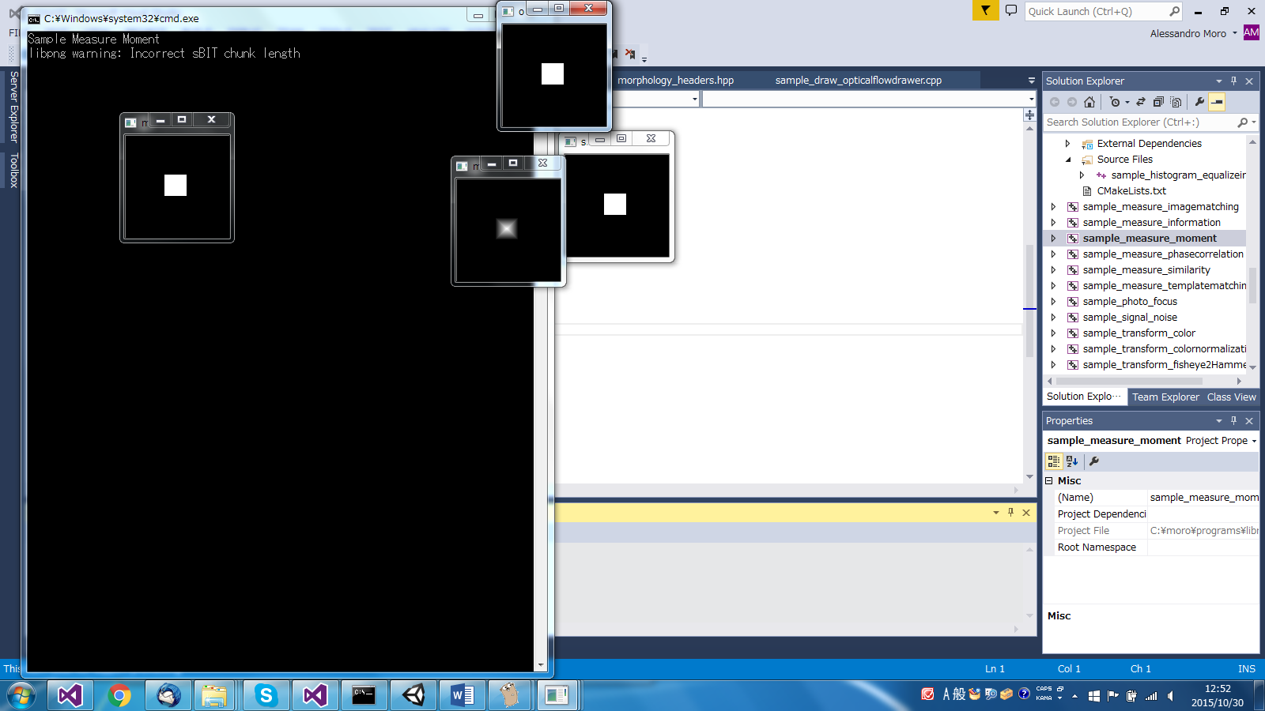

1. sample_measure_phasecorrelation

It measures the phase correlation (magnitude and direction)

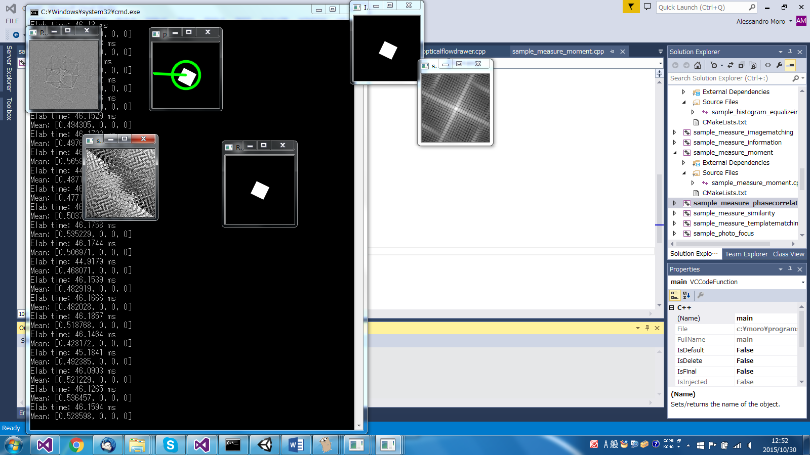

1. sample_measure_similarity

Measure the peak signal to noise ratio between two images.

http://en.wikipedia.org/wiki/Peak_signal-to-noise_ratio

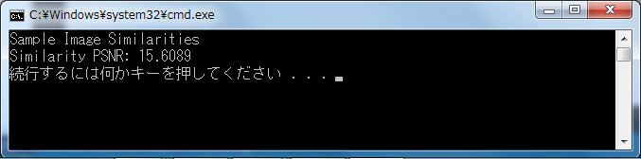

1. sample_measure_templatematching

Example of template matching based on cross correlation.

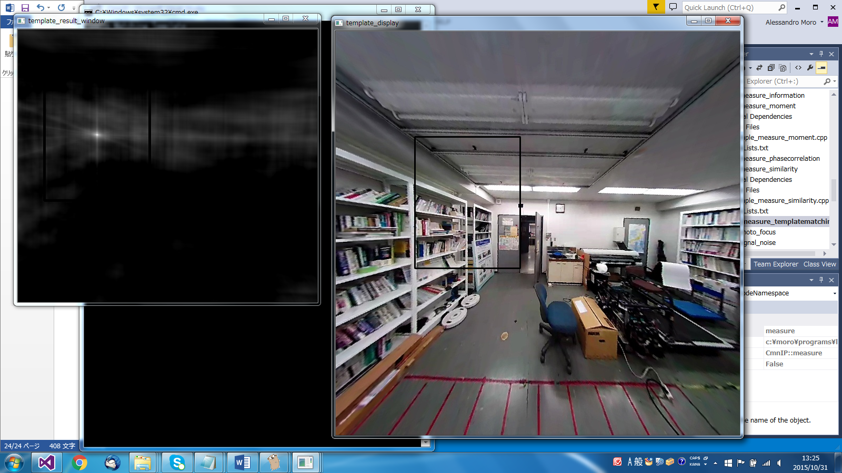

1. simple_photo_focus

It calculates the differences between a normal photo and its focus (used for autofocus).

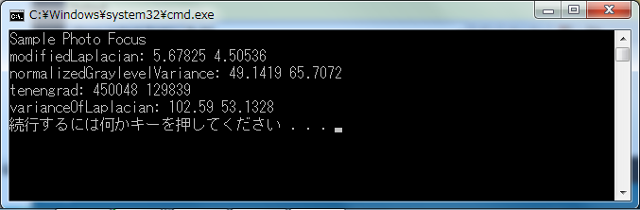

1. sample_signel_noise

Some noise generation

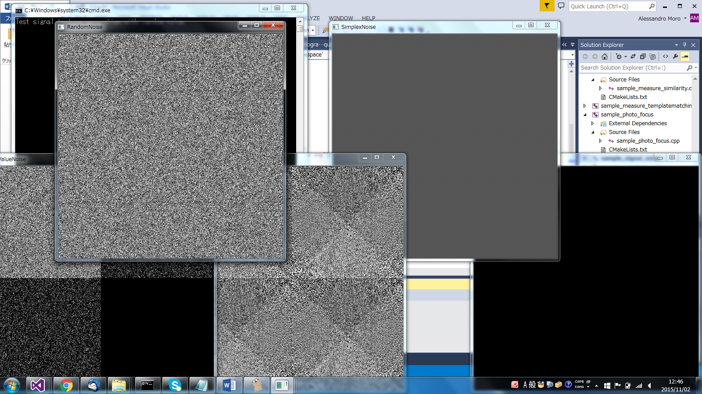

1. sample_transform_color

An example of how the color space is transformed



1. sample_transform_colornormalization

Example of color normalization

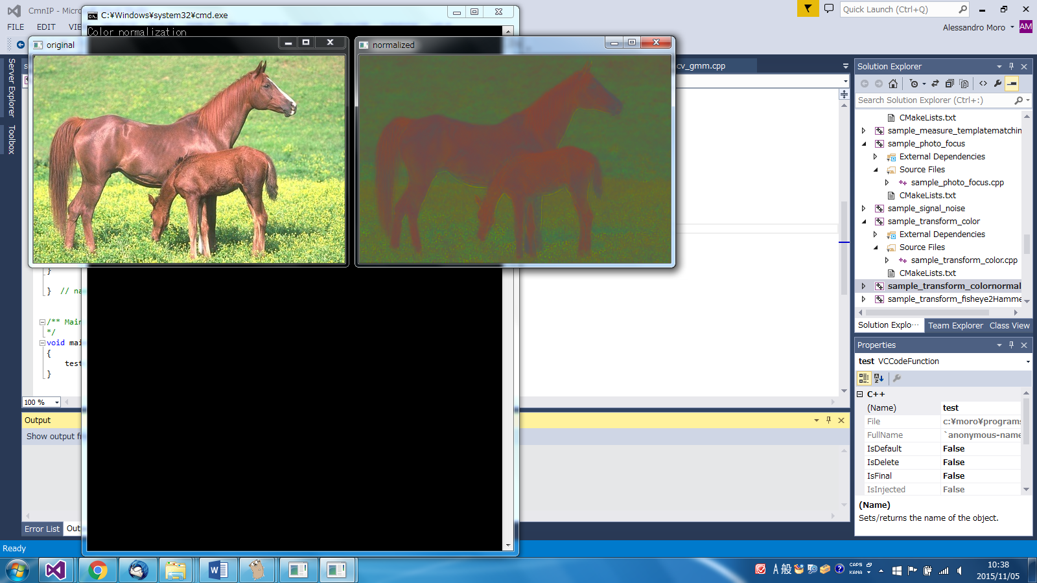

1. sample_transform_fisheye2HammerAitoff

An example of transformation from Fish eye lens image to HammerAitoff space.

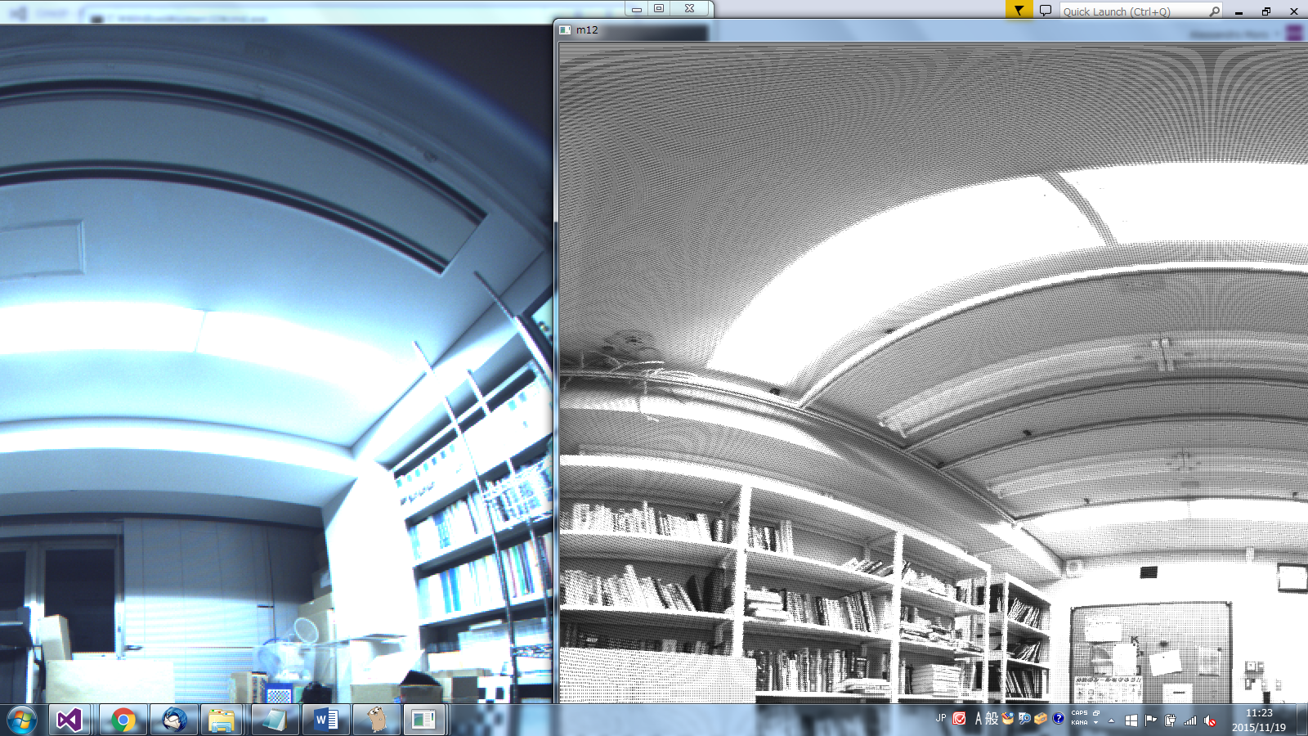

1. sample_transform_fisheye2perspective

Example transformation fish eye image in a perspective image with different orientations.

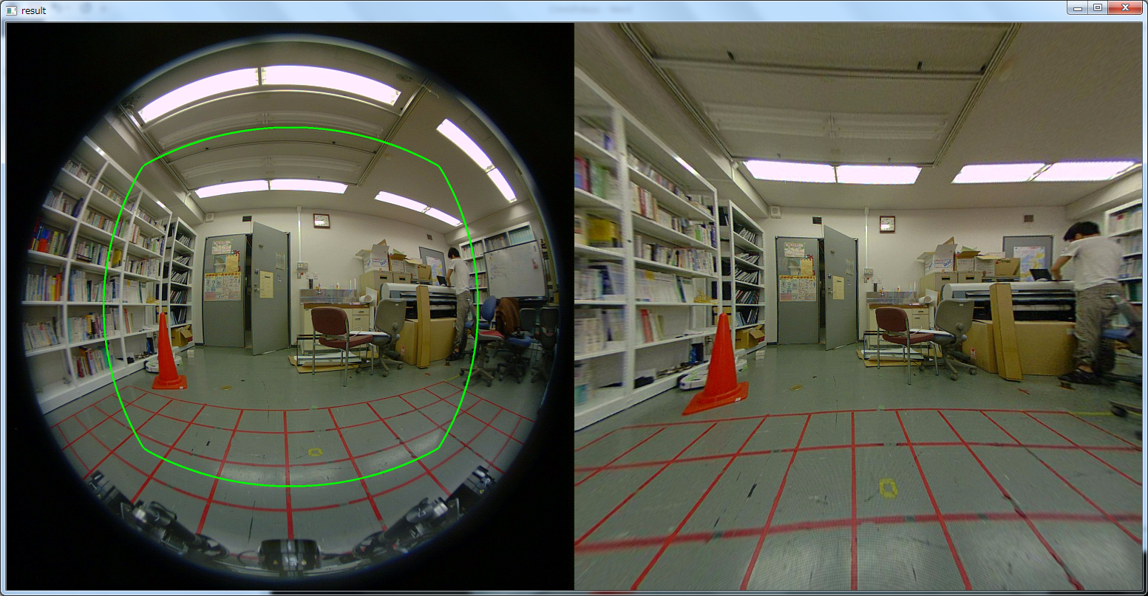

1. sample_transform_fisheye2polar

Example transformation fish eye image in a polar coordinated.

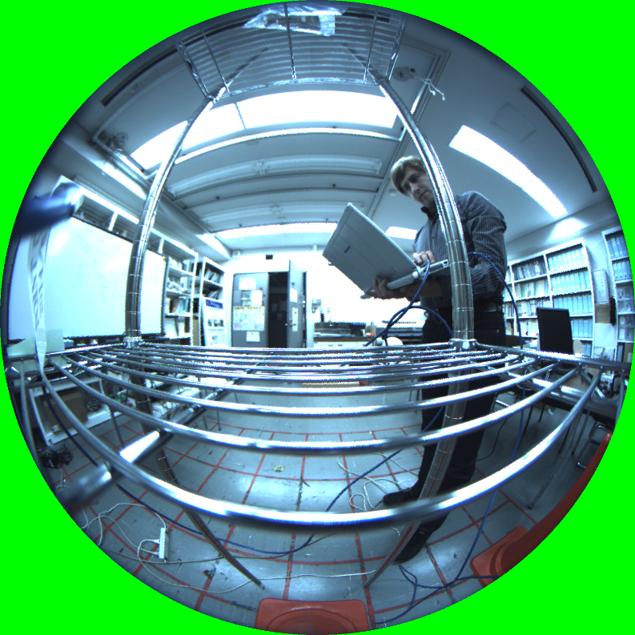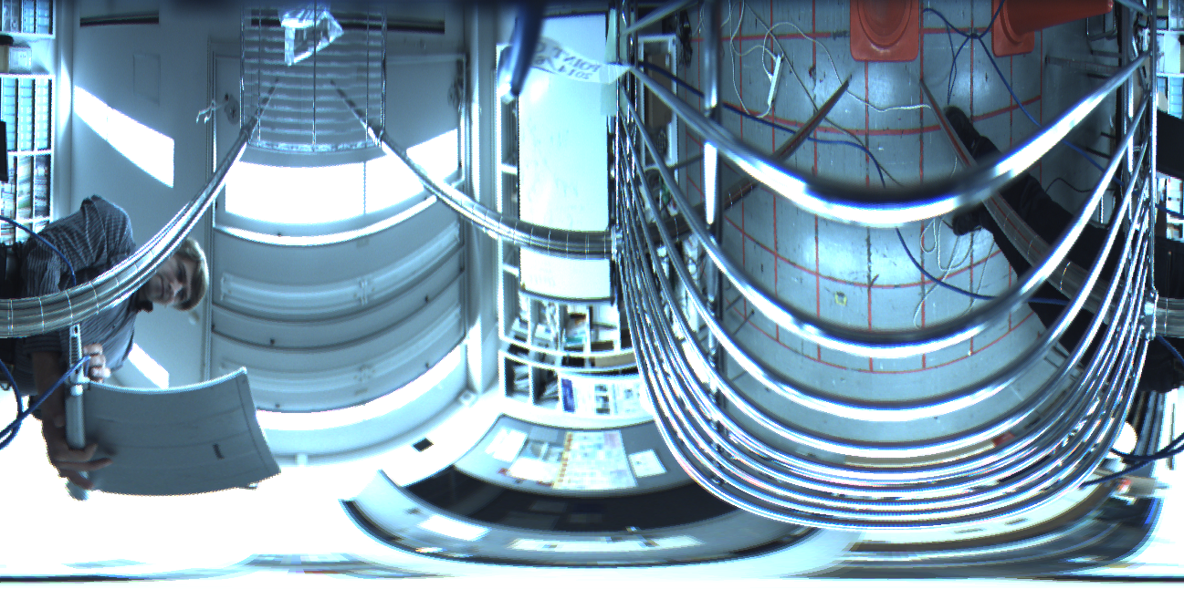

1. sample_transform_transform

Collection of signal transform functions (DCT, DFT, …)

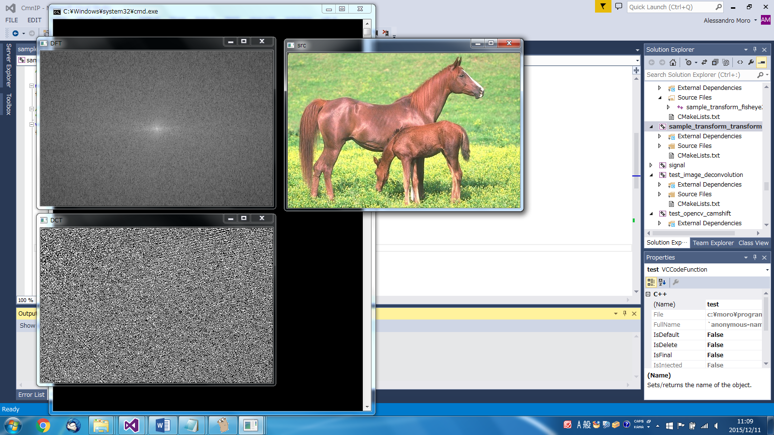

1. test_image_deconvolution

Example of image deconvolution (for instance de-blurring)

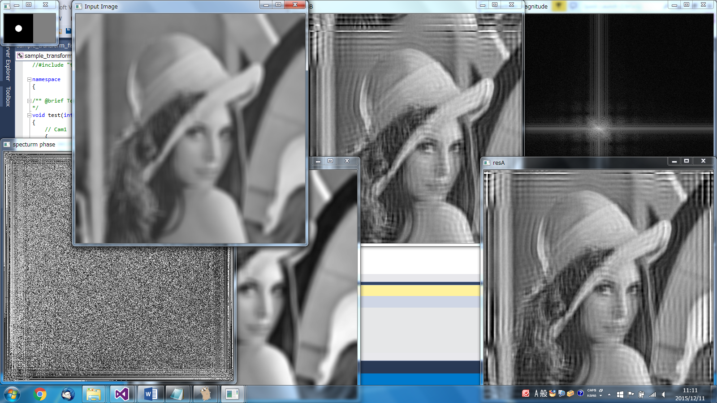

1. test_opencv_camshift

An example of camshift algorithm applied to the tracking of a selected region of interest.

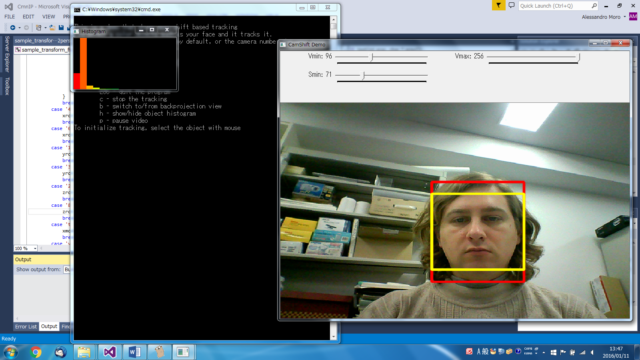

1. test_opencv_filter2d

An example of the opencv kernel based filter 2d.

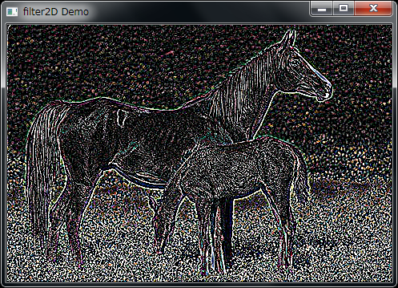

1. test_opencv_gmm

Example of Gaussian Mixture Models application for clustering.

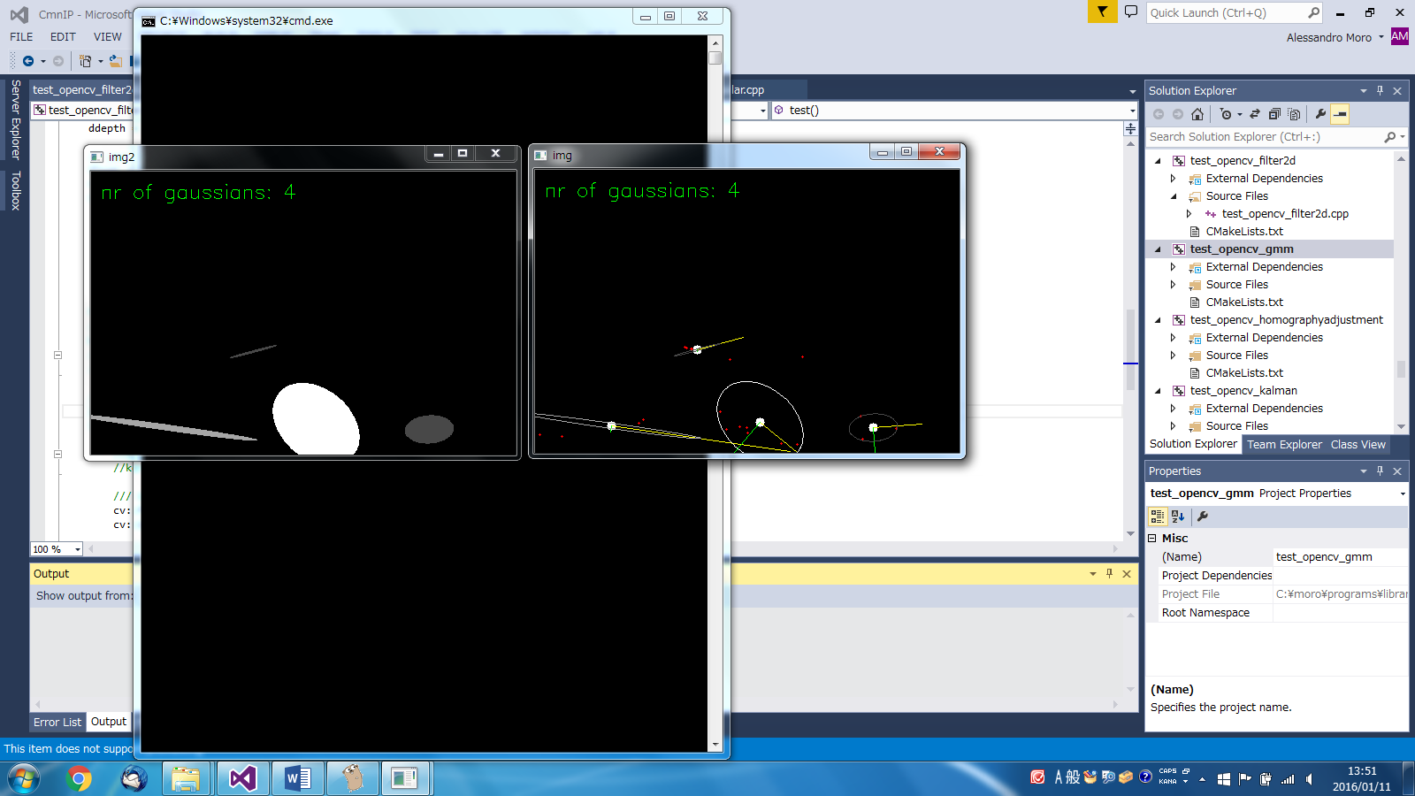

1. test_opencv_homographyadjustment

Example of 2D homography transformation.

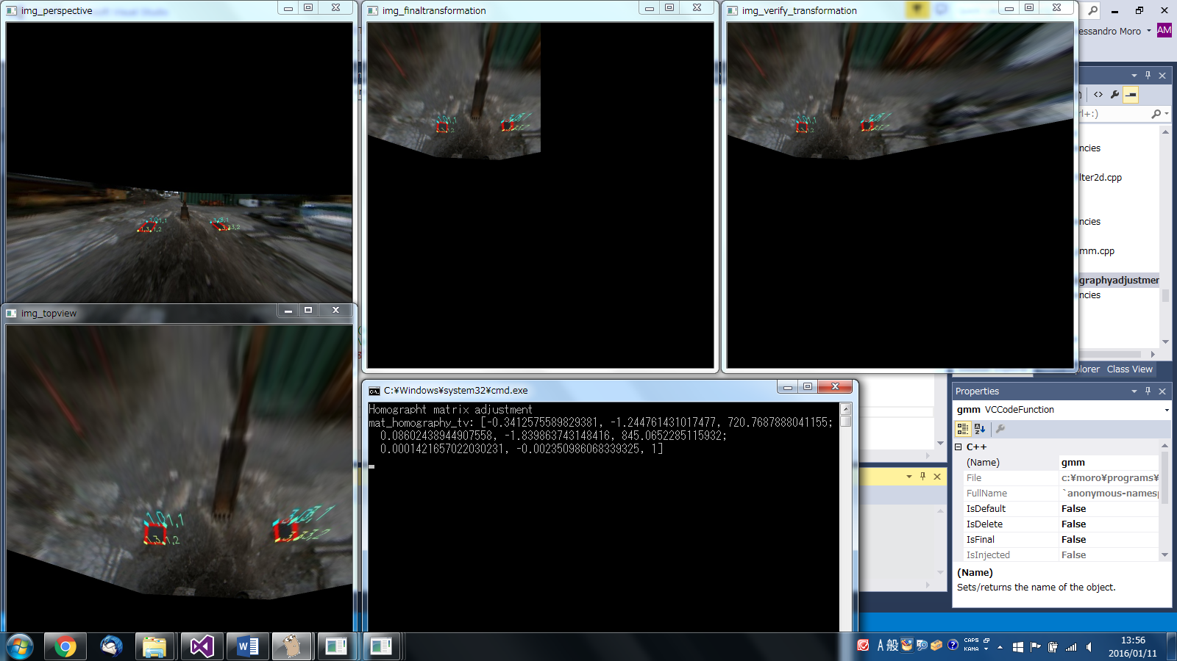

1. test_opencv_kalman

Example of Kalman filter to track the movement of the mouse.

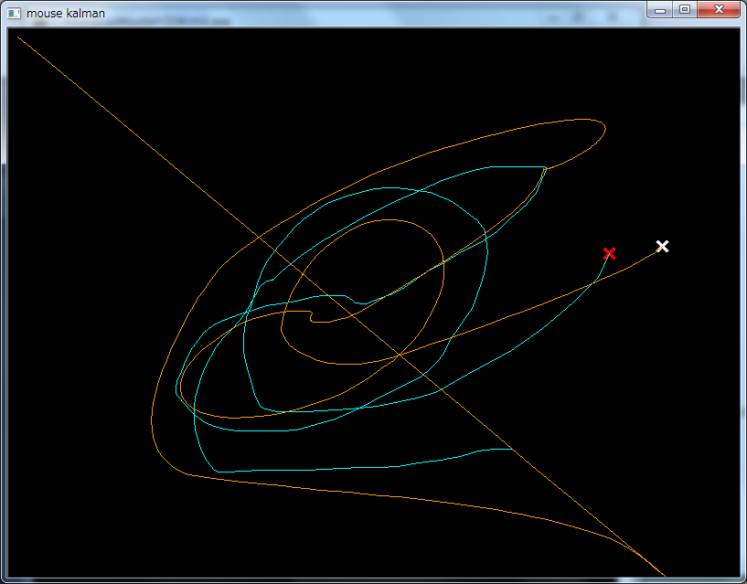

1. test_opencv_kmean

Example of kmean clustering applied to colored points and RGB points of an image.

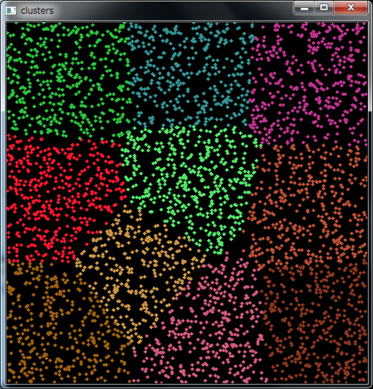

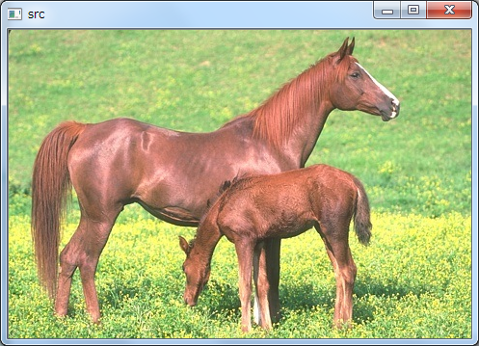

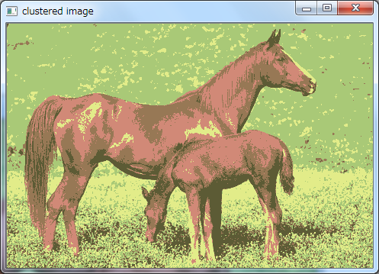

1. test_opencv_lk

Example of Lucas-Kanade feature points.

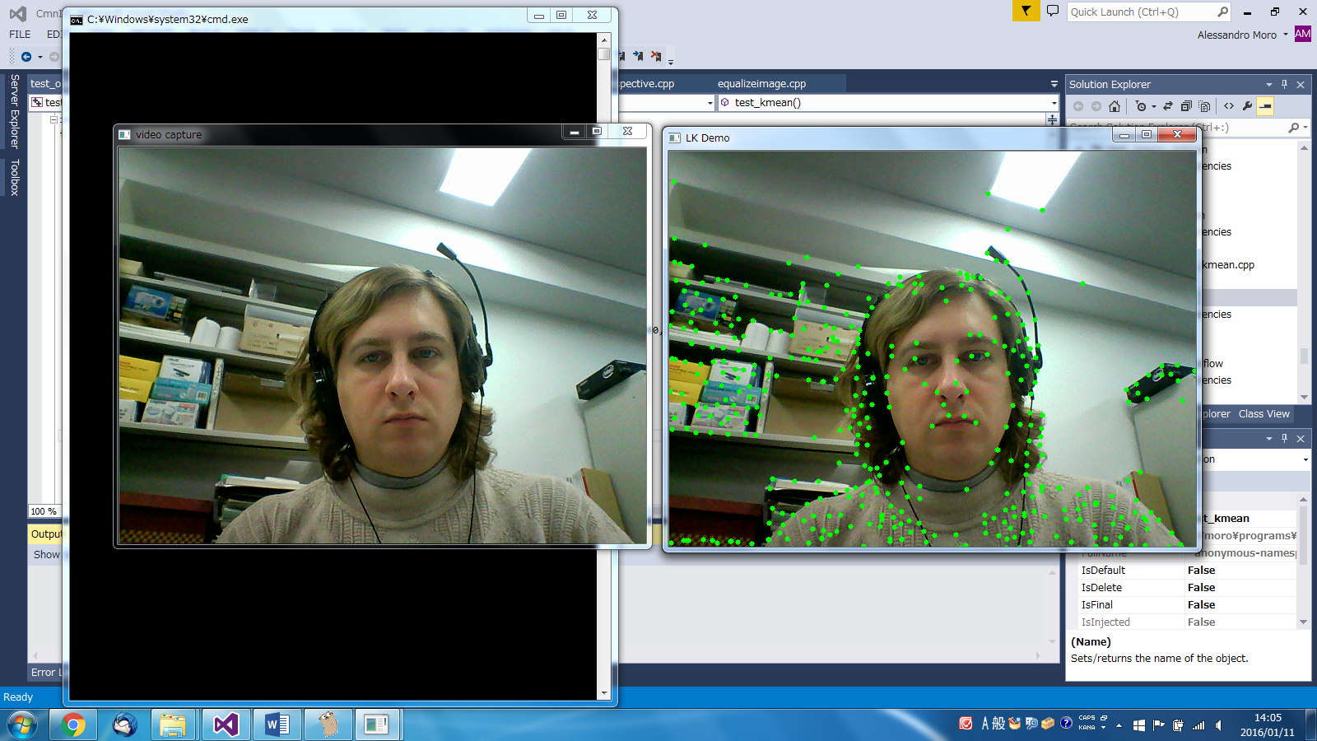

1. test_opencv_opticalflow

Some examples of visualization of the Farneback optical flow.

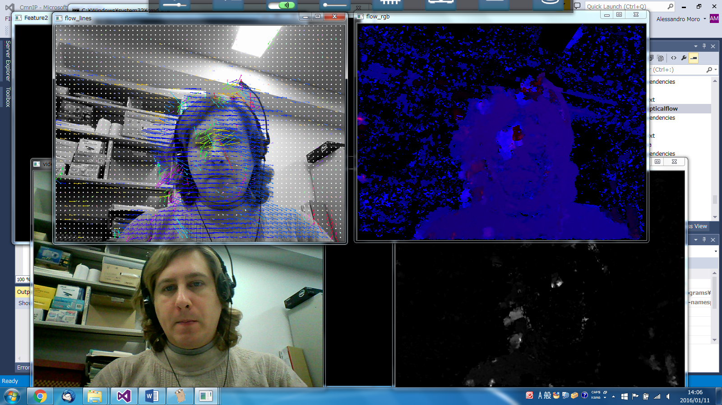

1. test_opencv_pca

Example of Principal Component Analysis to estimate main directions of black shapes..

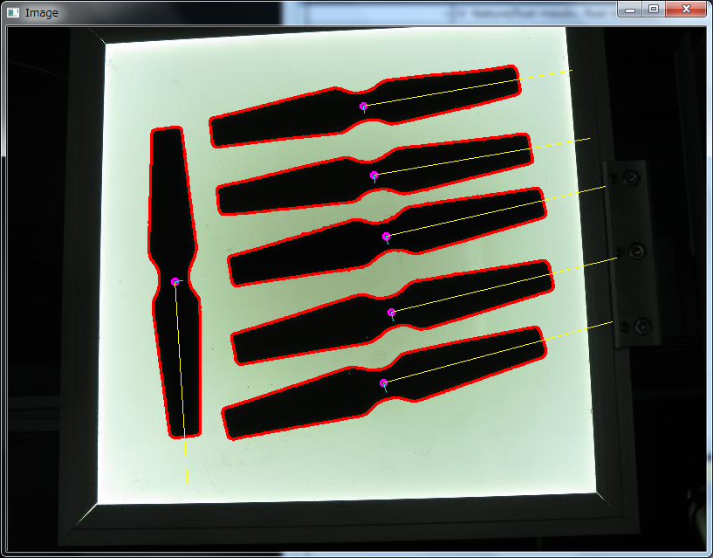

1. test_opencv_poissonblending

Example of Poisson blending. Opencv 3.0 has a faster implementation (Seamless cloning).

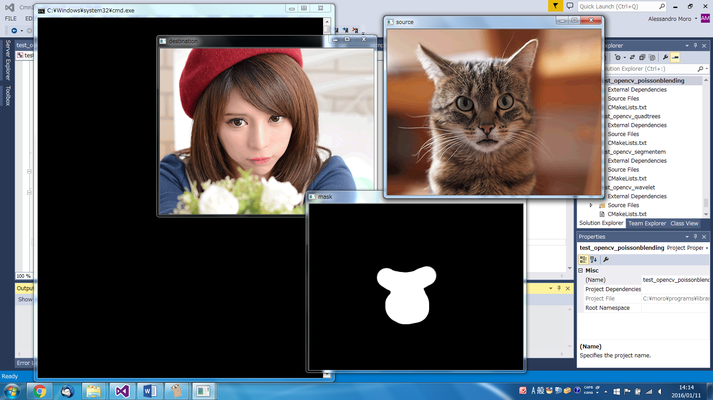

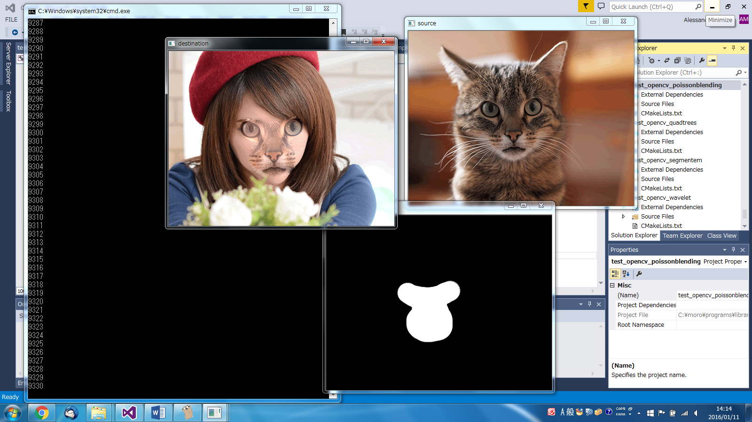

1. test_opencv_quadtrees

Quadtree image segmentation.

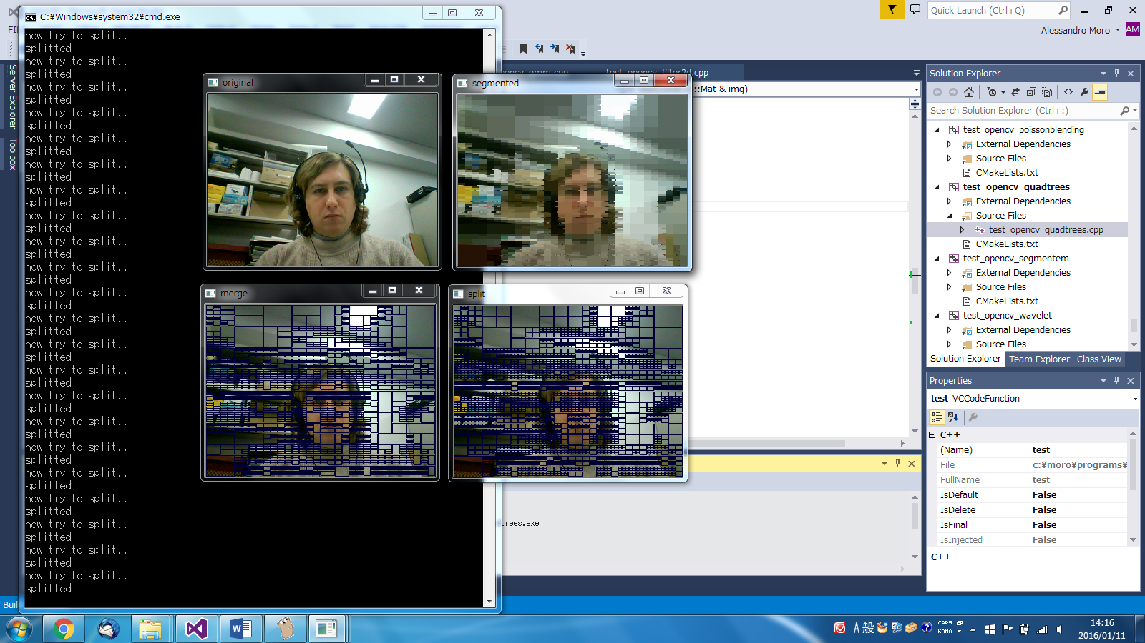

1. test_opencv_segmentem

Expected Maximization pixel clustering for image segmentation.

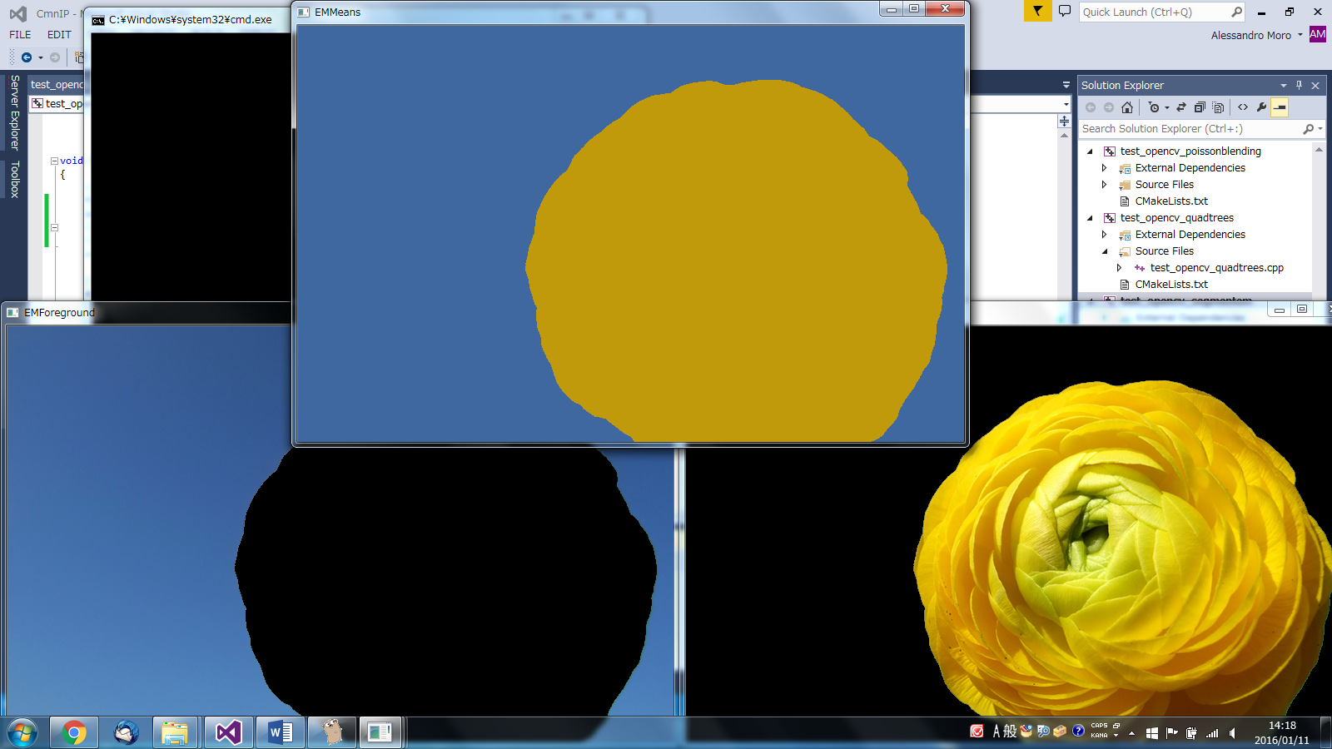

1. test_opencv_wavelet

Example of wavelet visualization for image filtering.

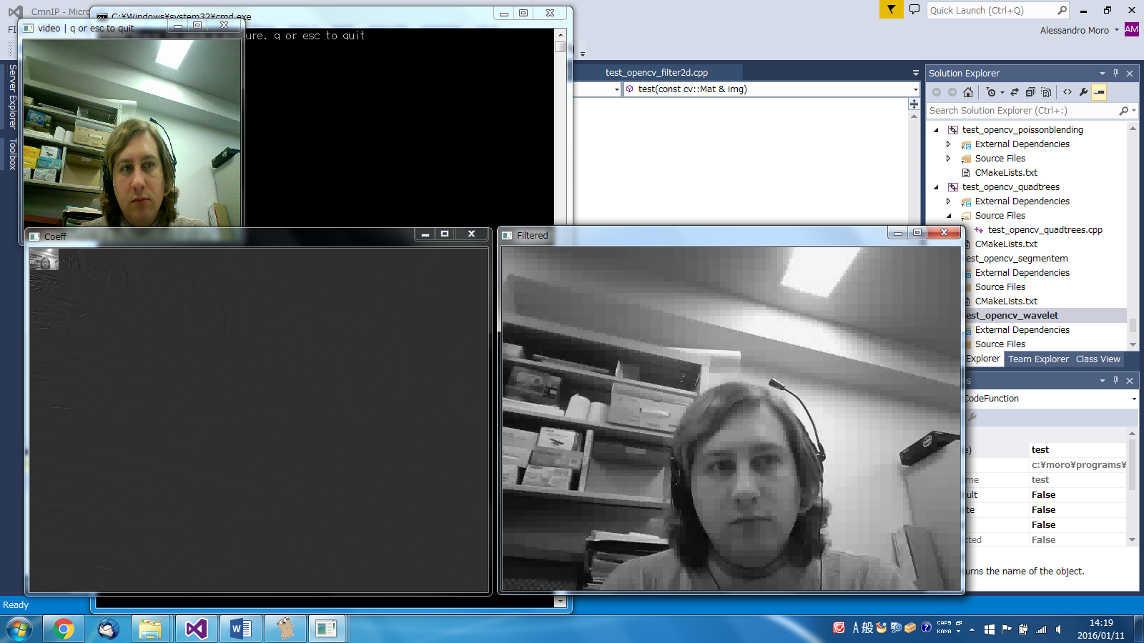

1. test_path2d_gravitypoint

Error minimization in a 2D trajectory estimation by gravity function knowing some landmarks location.

